Technical Assessment Write-up
  - Jeroen Buil

Task 1: FPVS

Approach to get timing right: rAF
Using setTimeout/setInterval is obviously not the right way to approach this a case like this. Due to overhead and system usage you simply cannot assure that EXACTLY after the timeout the stimuli picture is displayed. These timers accumulate, which means each delay causes a further drift away from the actual moment you wish to display a stimuli; the longer the sequence the larger the drift at the end will be.
Instead I am relying on requestAnimationFrames (rAFs), which tell the browser you wish to perform an action and tells the browser to do this before the next frame is repainted. Such rAF callbacks are synced to a browser’s actual display refresh (typically ~60 Hz / 16.67 ms/frame ) and unlike timers mentioned before, they don’t accumulate.
rAFs can be used to reduce the compute needed when nothing is happening, or to make animations run smoother (because you can do them only as many times as the frames are actually updating). But in this use-case I can use them to log when a frame is updated and display a
Actual implementation:
I am updating displayed stimulus inside a loop that is called ‘stimulusUpdateLoop()’. This loop is called using the requestAnimationFrame function executes the loop before the next frame renders and it passes a timestamp.
The function itself does 4 main things:
- sets the startTime on first call => this is used as time reference point for all subsequent rAFs.
- Updates the currentIndex whenever the elapsed time passes into the moment the next stimulus should appear => this triggers Vue to display the next stimulus
- Logs the onset times in the store => used for the result view to calculate timing stats
- Updates the rafId and schedules a new iteration of this same loop for the next frame render.
I
function stimulusUpdateLoop(timestamp) {
if (startTime === null) {
startTime = timestamp
// Stimulus onset logging for first stimulus (index=0) in sequence
store.onsetLog.push({
index: 0,
isOddball: store.sequence[0].isOddball,
onsetMs: 0,
})
}

const elapsed = timestamp - startTime
const targetIndex = Math.floor(elapsed / frameIntervalMs) // updates targetIndex when it is time to show the next image in the sequence

// Update the currentIndex if the targetIndex updates => this triggers a rerender of the sequence viewer with the new image
if (targetIndex > currentIndex.value && targetIndex < store.sequence.length) {
currentIndex.value = targetIndex
// Stimulus onset logging:
store.onsetLog.push({
index: targetIndex,
isOddball: store.sequence[targetIndex].isOddball,
onsetMs: elapsed,
})
}
// if all images in the sequence have been displayed, then move to the results view
if (targetIndex >= store.sequence.length) {
store.goTo('results')
return // sequence done => don't schedule another frame (go straight to onUnmounted instead)
}

// update rafId and reschedules this same function for the next frame
rafId = requestAnimationFrame(stimulusUpdateLoop)
}

// When RunView is mounted store animation frame request id
onMounted(() => {
rafId = requestAnimationFrame(stimulusUpdateLoop)
})
// When RunView is unmounted cancel animation frame request
onUnmounted(() => {
if (rafId !== null) cancelAnimationFrame(rafId)
})

How accurate is my approach?
The stats below show very minimal difference between the mean and the target rate, with a small std (<1ms). This applies to both the random base stimuli as the oddball stimuli (every N-th frame). Also no dropped stimuli are observed, which would be disastrous for an experiment. I would conclude that the stimuli display accuracy is high, but it is not perfect. Some observations can be made.
- Min interval is smaller than target interval?
While my approach ensures that a stimuli is never displayed too early, the min interval are still below the target, this is not a bug, but instead happens when e.g. 1 stimulus is delayed and the next one is perfectly on time, causing a delta that is smaller than the target.
- First stimulus interval higher than the rest?
The worst case (vs the ideal time) happens to always be the interval between the first and the second stimuli. This can likely be attributed to the first time image decoding cost. With ~4-7ms (depending on the run) it is not even 5% deviation from the base rate, but at higher stimulation frequencies this certainly isn’t ideal behaviour. Luckily this time can be reduced, see ways to improve: ‘ Image preloading.’
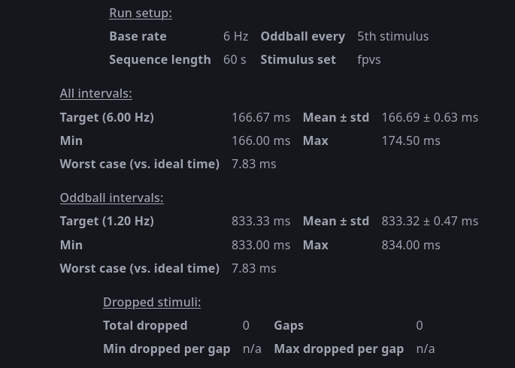
Figure 1: Interval and dropped stimuli stats.
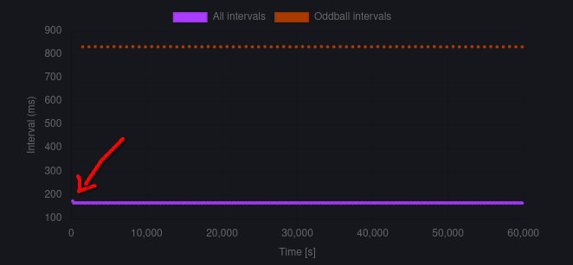
Figure 2: Stimuli interval timings. Show consistent interval timings for all the stimuli (oddball intervals displayed separately). Only the first stimulus interval is significantly higher than the rest (marked by red arrow).
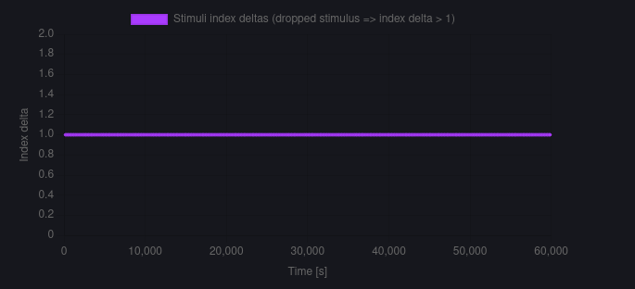
Figure 3: No dropped stimuli. All stimulus log entry have a stimulus index delta of 1 meaning no index is skipped.
Ways to improve and known limits:
- Image preloading. Upon first use the stimuli images are fetched and loaded, which creates overhead. The stimuli files are very small and there aren’t many stimuli files either, so the overhead isn’t big. The interval plot show this as it would show a higher interval the first time a stimulus is loaded. This effect isn’t negligable and can solved by just preloading the images once before starting the loop. Could’ve, would’ve, should’ve in a real world project.
- rAF only fire once per display refresh. So timing can never be finer than the screen’s own refresh interval and jitter on the order of 1 frame is an inherent property.
- Background tab throttling or CPU load can affect timing. If a browser decides to throttle or even pause the activity of this webapp tab or when the CPU load spikes for some reason, this can delay a frame, or even pause the rAF entirely. These risks are harder to control, but can be reduced by good computer management and code optimisation.
- Back button is visible during the ‘stimuli sequence’. Yes, I am aware in an actual experiment this is unwanted as it draws attention. This addition however, made debugging and testing much easier, as I was able to interupt a run.
A nicer way to implement this desired interrupt option is with a keyboard button press.

Task 2

LLM usage:
Claude Code is usually my go-to tool if I want help with coding.
I find it most helpful for linting, writing docstrings (i.e. for functions) and writing and updating readme files (live is too short to write README’s by hand...).
For debugging and scaffolding a combination of stackoverflow and LLM’s can help solve respectively obscure and generic problems.
For full transparancy: the csvExport function in task 1 is written completely by Claude. This function is not rocket science, is easily verified and is a relative unimportant feature for this task that is still wanted to include despite time constraints.

